**DATA ANALYTICS POWERED BY TABLEAU**

**PROJECT TITLE:**

**Uncovering The Hidden Gems Of The Gaming Industry**: **A Comprehensive Analysis Of Video Game Sales.**



**SUBMITTED BY:**

**TEAM ID:** NM2023TMID00694

**TEAM LEADER:** VIJESH. V.K

**TEAM MEMBERS:** ASHRITHA. S

SUMAIYA RAASHIDA. A

BHAVISREE. P.R

**PROJECT REPORT**

1. **INTRODUCTION**
   1. Overview
   2. Purpose
2. **PROBLEM DEFINITION & DESIGN THINKING**
   1. Empathy Map
   2. Ideation and Brainstorming Map
3. **RESULT**
4. **ADVANTAGES & DISADVANTAGES**
5. **APPLICATIONS**
6. **CONCLUSIONS**
7. **FUTURE SCOPE**

**A COMPREHENSIVE ANALYSIS OF VIDEO GAME SALES.**

**INTODUCTION**



As the video game industry is gaining increasing popularity and attracting more and more publishers, we are interested in unveiling noticeable insights about the relationship among genre, publisher, release date and sales of different titles. Development of games with a focus on interactive experiences can drive the market demand. To this aim, we will inspect a dataset containing a list of more than 16000video games sold from1980to2020.

**EMPATHY MAP**



**IDEATION & BRAINSTORMING MAP**



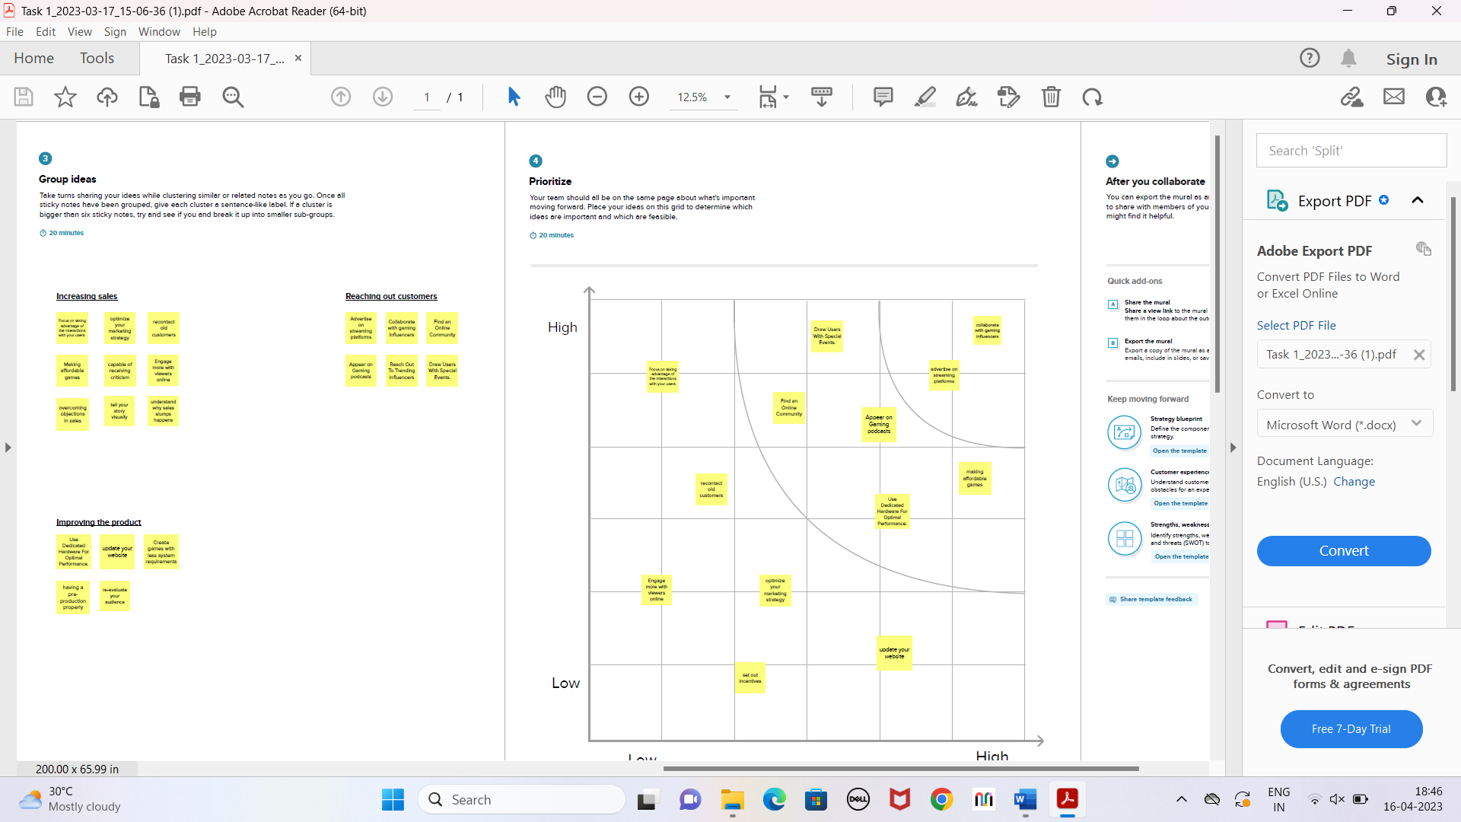

**RESULT:**

**DASHBOARD**

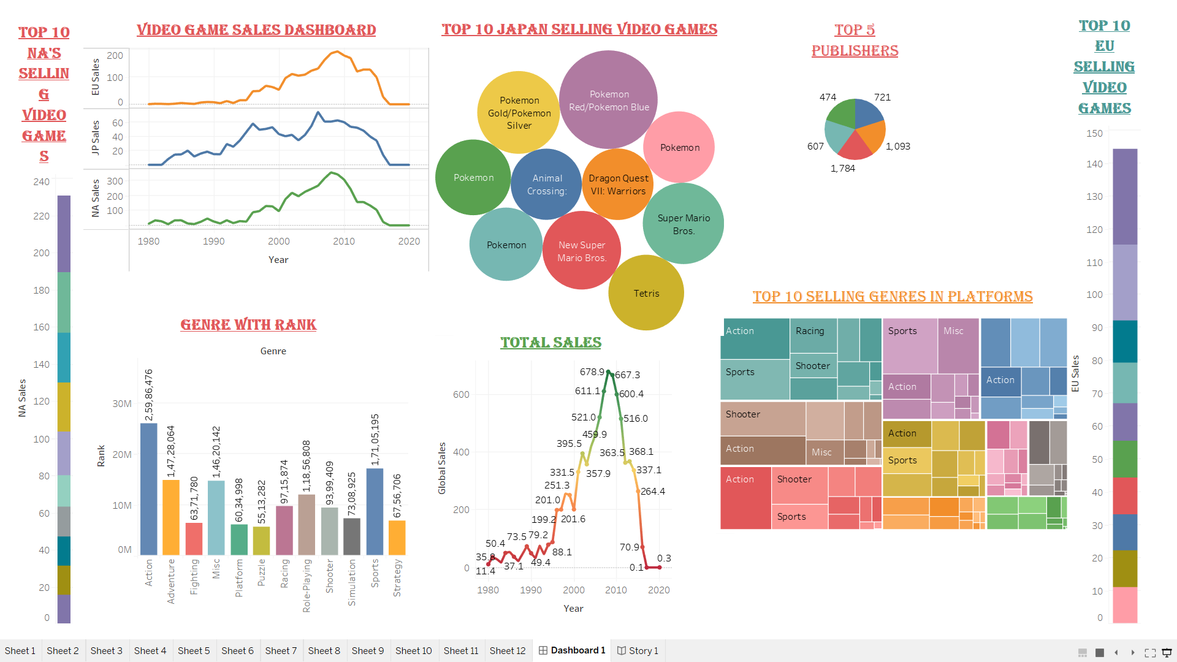

**STORY**

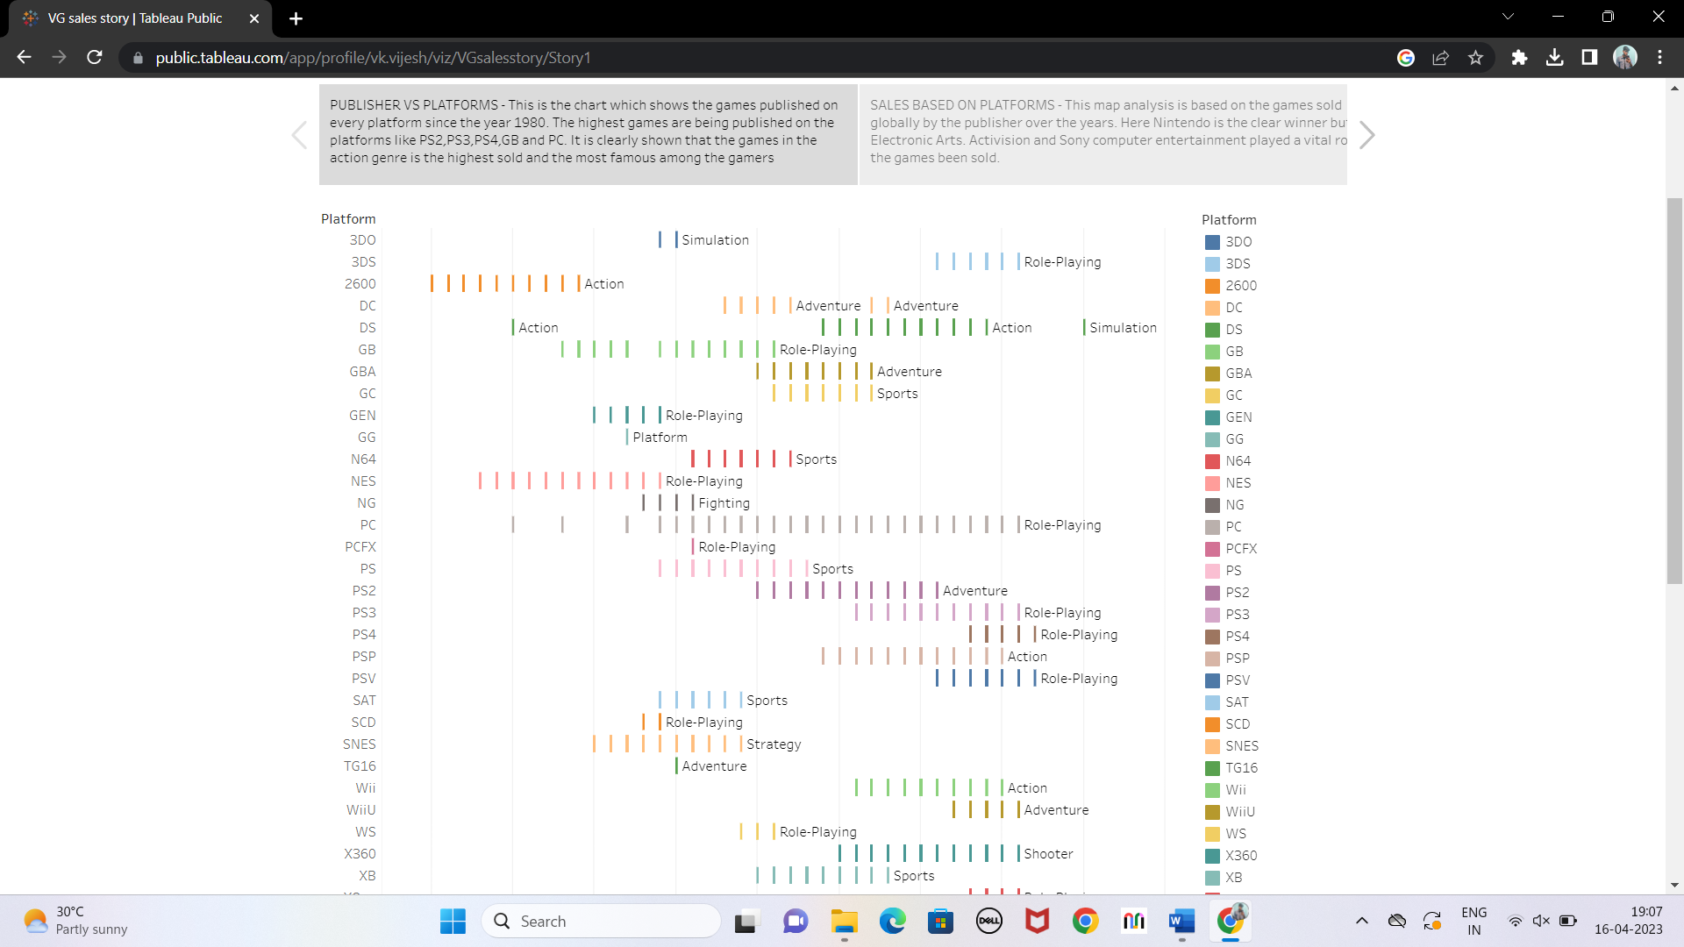

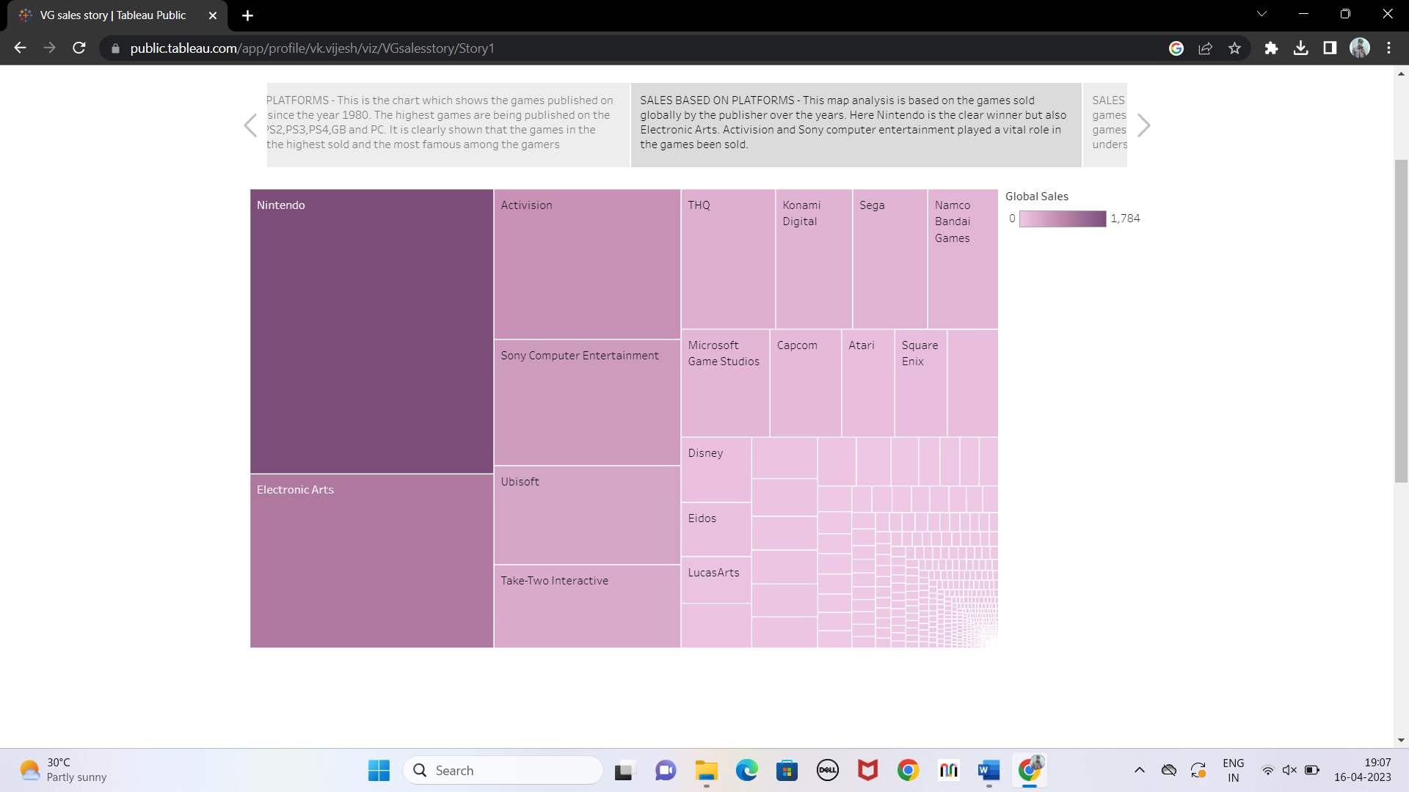

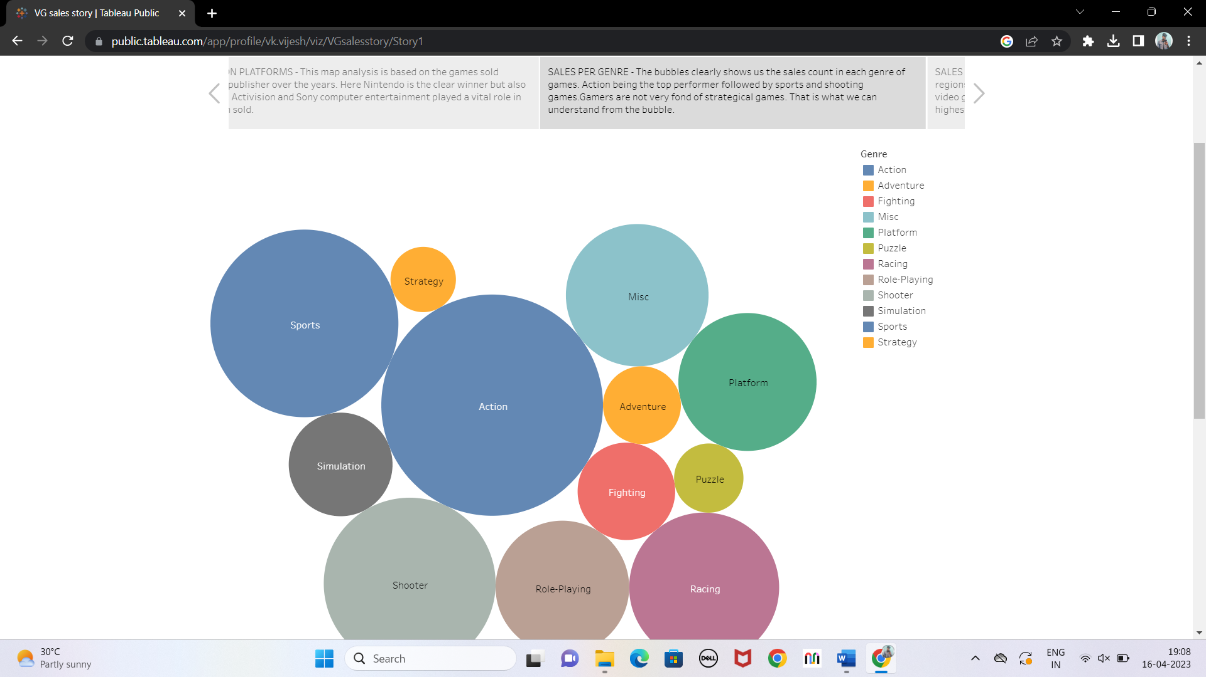

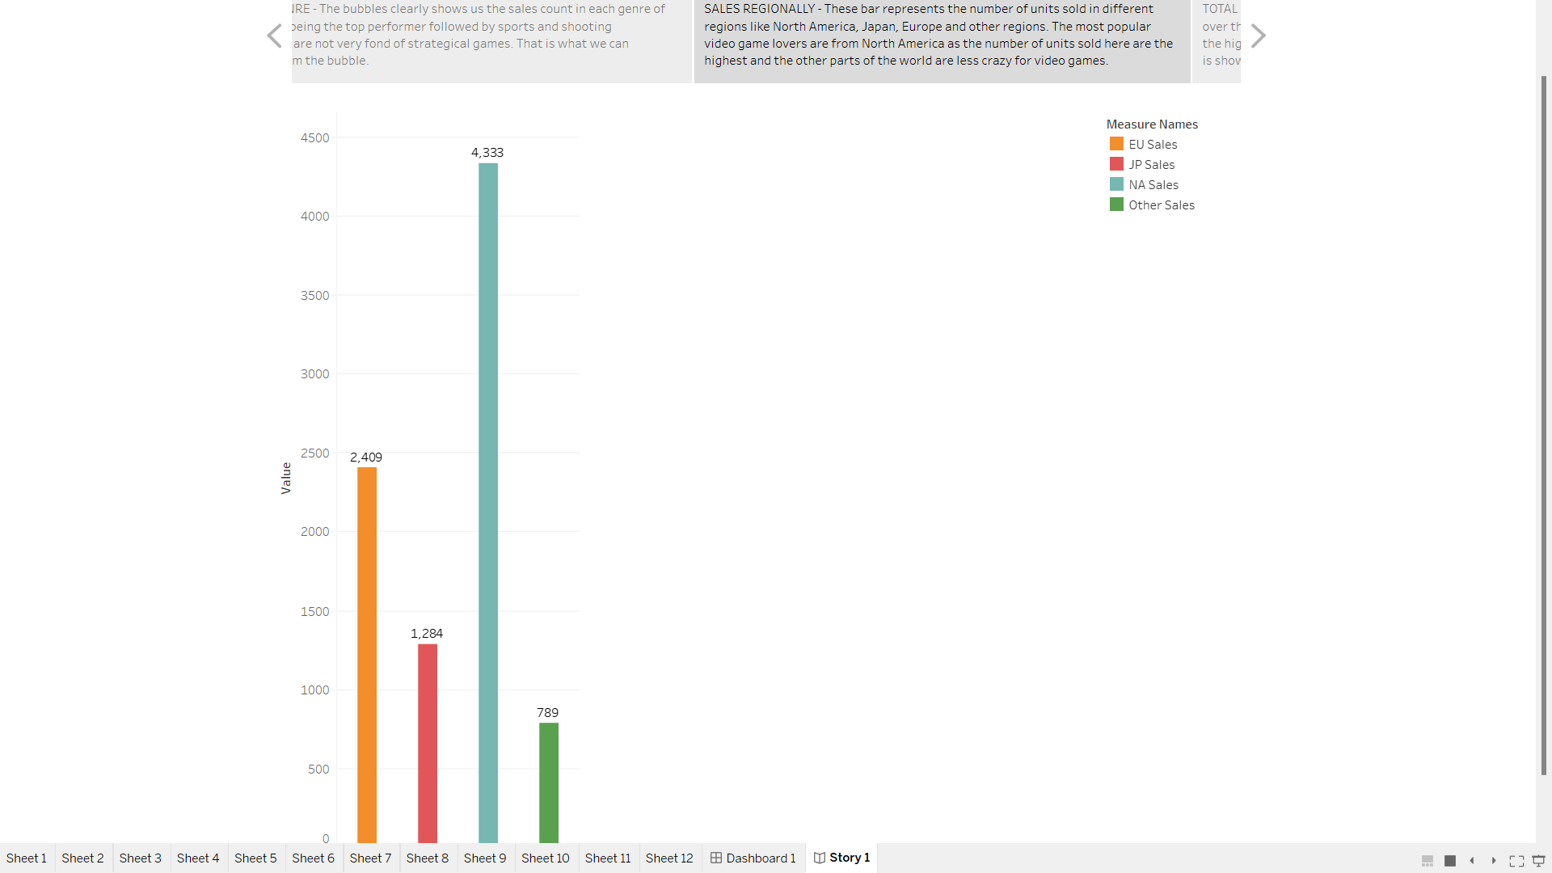

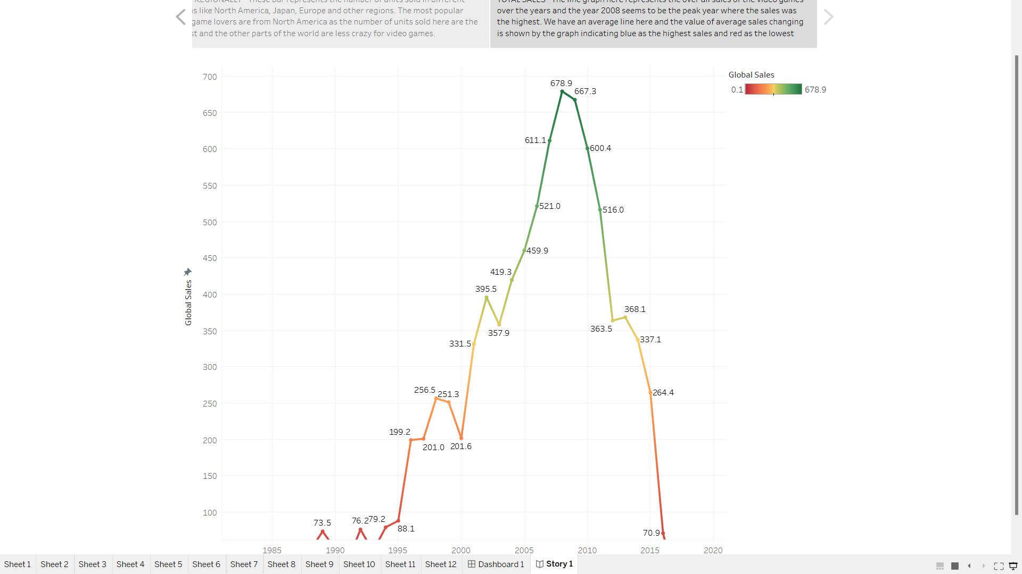

**WEB PAGE**



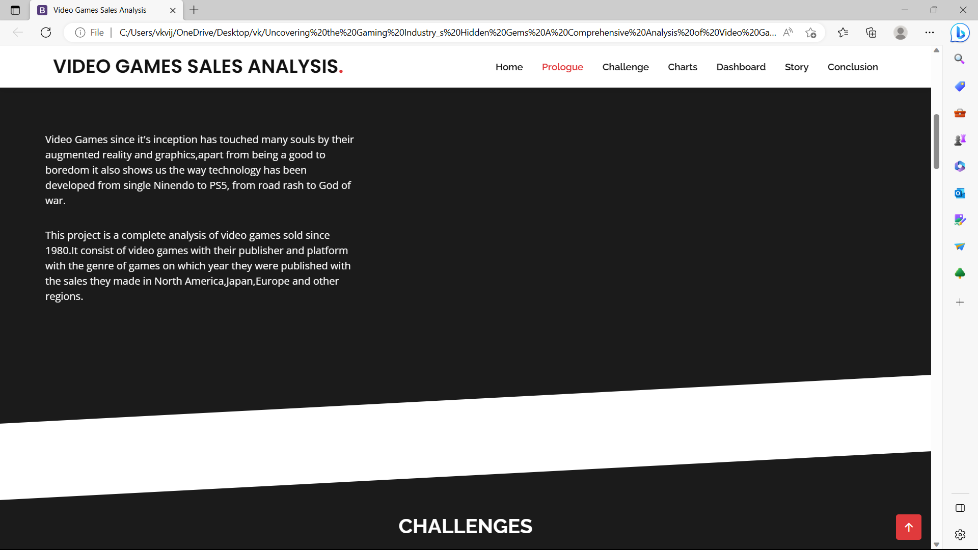

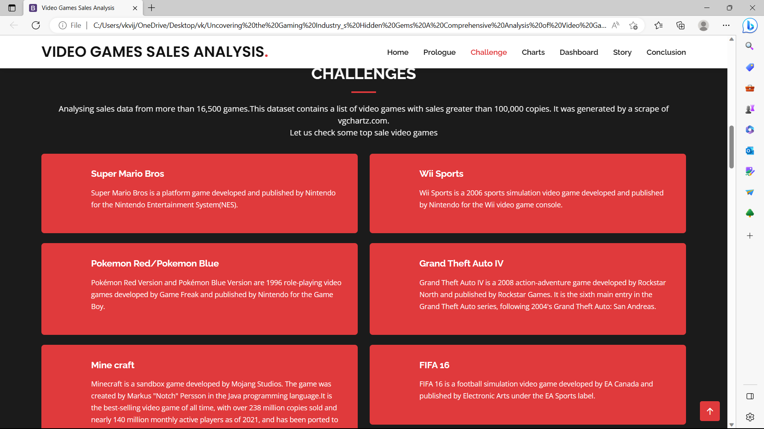

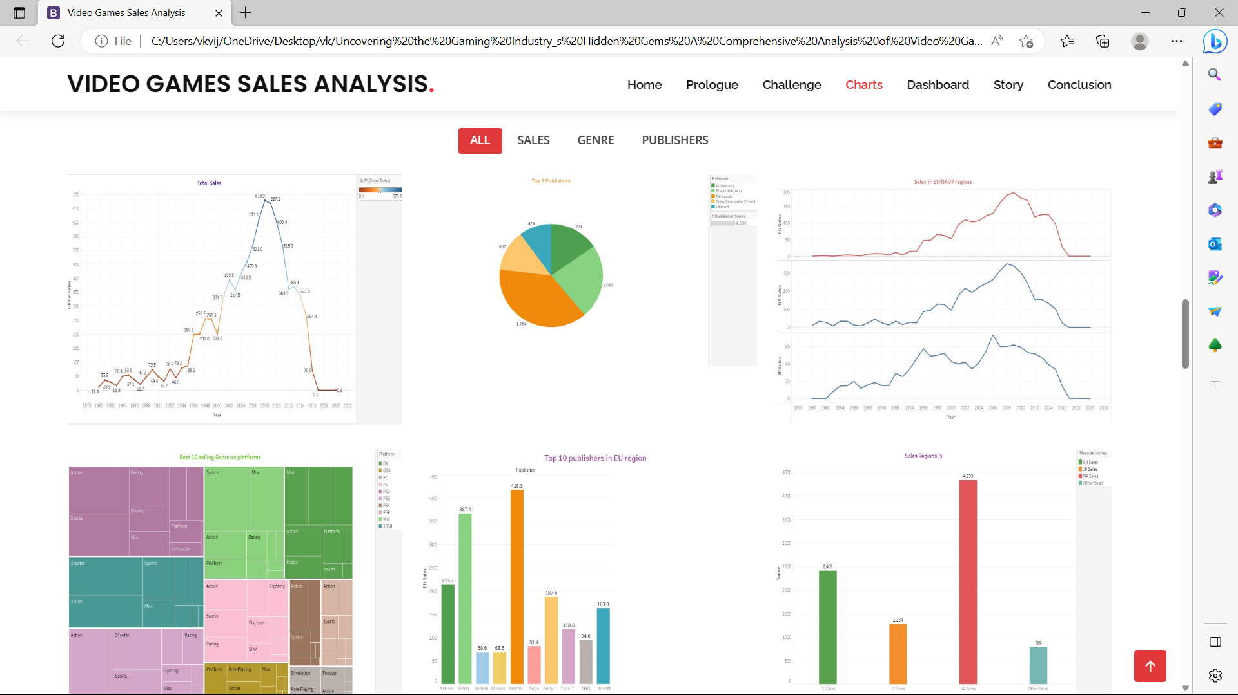

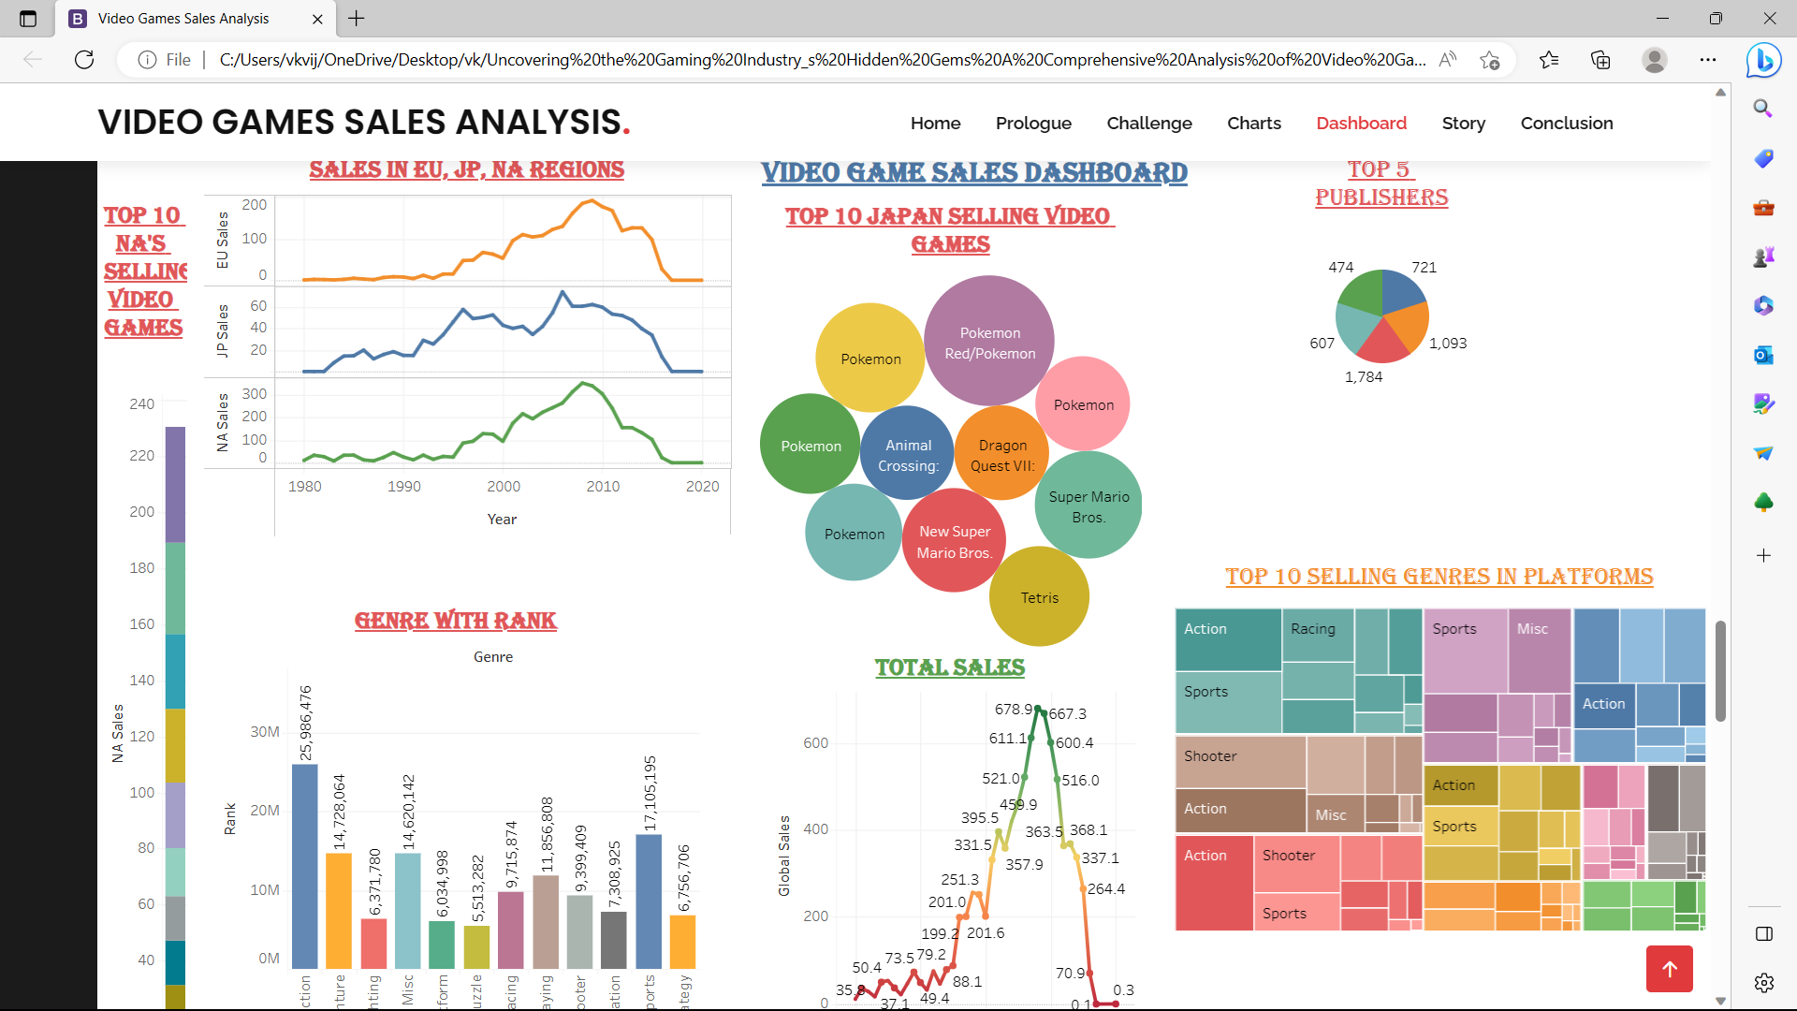

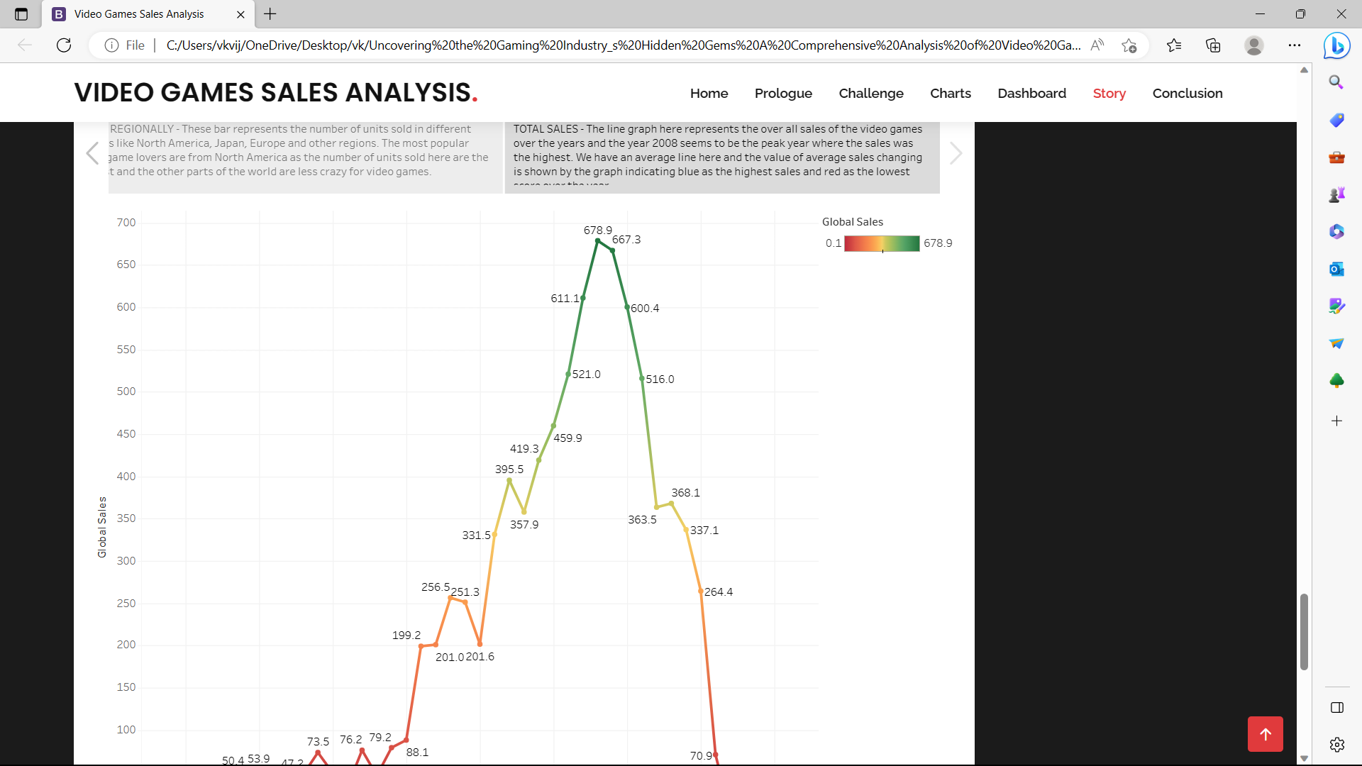

**ADVANTAGES & DISADVANTAGES**

**ADVANTAGES:**

* Market Expansions.
* Better Compliance.
* Diverse Opinion.
* Helps in concluding where to invest.

**DISADVANTAGES:**

* The industry grappled with varied headwinds ranged from worsening macroeconomic conditions, a post pandemic softening in demand, ongoing supply issues and significant increased legal.
* Elevated risk of aggression.
* Some games promote gambling.

**APPLICATION**



It encompasses the development, marketing, and monetization of video games.

**CONCLUSION**

* It is best option for the games releasing in PC and also if you are looking for action games look for the publisher "Nintendo" as they have sold the highest number of games.
* The love for the video games was increasing exponentially till 2008 but it is gradually decreasing since then, this is due to the lack of creativity, awareness or interest. This is the reason why most of the games are sold in NA as compared to other parts of the world.
* There are lots of effort going into creating a single game and due to modern era mobile games, other platforms getting deprived of the attention which had created a lot of awesome experience for the gamers from 1980 till now.

**FUTURE SCOPE**

Virtual reality (VR) has the potential to revolutionize the gaming industry by immersing players in a fully interactive and realistic digital world.